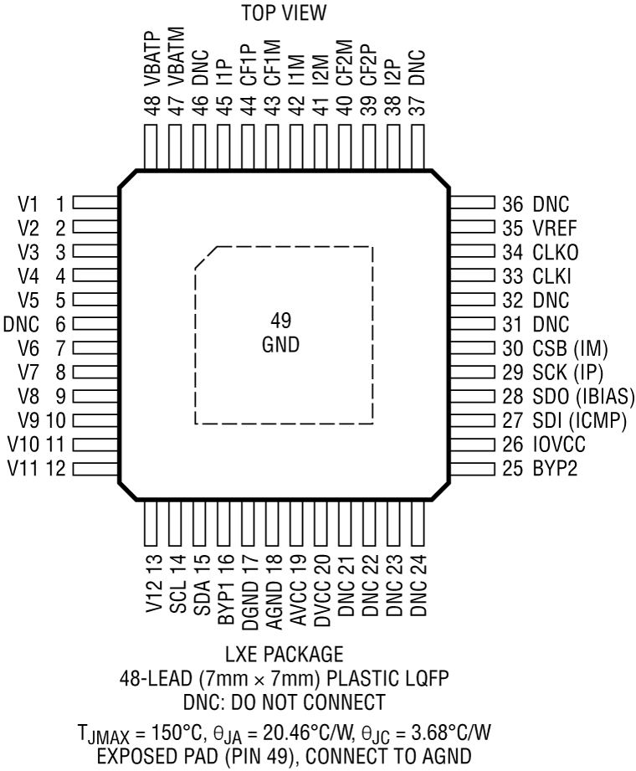

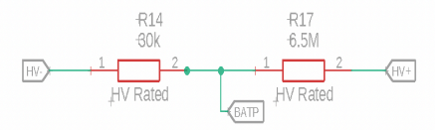

Max battery voltage: 378V => Max VBATP-VBATM = 30k/(30k+6.5M) x 378 V = 1.736 V

Range of VBATP from datasheet: 0 to VACC

Required range: 0 – 1.736 V => VACC > 1.736V

So, give VACC 5V supply.

VBATP is 15bit voltage measurement => 0V gives 0, 5V gives 2^15-1 = 32767 reading

sensorValue = digitalRead(VBATP) – digitalRead(VBATM)

batp = sensorValue\*(5.0/32767)

accVoltage = batp\*(30k + 6.5M)/30k